# 8

# Assessment: *Making the Grade*

## How I Grade Students vs. How You Grade Students

All students know that different professors grade differently. We’d be willing to bet that your experiences in this area mirror ours, and that you’d agree that the differences go much deeper than we could have imagined. It’s not just a question of one professor being a tough grader while the other is easy, or one grading on established intervals (93-100 = A, 90-92 = A–, 87-89 = B–, 83-86 = B, etc.) while the other grades “on the curve.” It’s more a question of style: how much feedback students receive on their work and in what form, how the various components in any individual assignment are evaluated to come up with an overall grade for that assignment, and how final grades are computed, especially if doing so involves grades of differing weights. There also appear to be quite different “cultures” concerning grades in the sciences and the arts. While students in all disciplines are understandably concerned about their grades — if for no other reason than to maintain the grade point average (GPA) required to keep their financial aid or to avoid a clash with parents — those in the sciences seem to desire more precise accounting than those in the arts. Add to these factors that students in an interdisciplinary course are, by definition, constantly being put into situations outside their comfort zone, and it’s easy to see that the wave of students complaining about grading can be a tsunami waiting to happen.

One can discuss grading philosophies forever, but we begin from the premise that if students put reasonable amounts of effort into the coursework, they should get “paid” with a decent grade, which we consider to be B– or better. In fact, one of us believes that all students walk in with an A and it’s the student’s responsibility to maintain that grade. This is especially true in an experimental course such as our *Sound Thinking*, where we know that some of the assignments and our expectations of students’ work may come across a bit “fuzzy.” If our own experience can be used as a benchmark, you will find that many times your students will come up with solutions and approaches that you haven’t even thought of yourself. As discussed previously, as professors and teachers you want to encourage that creativity, which you can do by taking students’ willingness to take risks and try something new into consideration, even if the final result doesn’t work out exactly as planned. However, no matter how “fuzzy” the assignment, it’s pretty easy to tell an assignment that was done on the way to class from one that a student really put some thought into. Things get trickier with assignments that are done in teams (which most of ours are, more on this later), but “the cream still rises to the top” when it is truly present. Thus, you will want to set up a grading scheme that includes subjective evaluation of students’ effort as well as objective evaluation of what they produce.

## Grading Criteria

As a case in point, we devised a system for setting up all of the assignments for our *Sound Thinking* course that we believe can be applied to any type of course. (All of our assignments can be viewed by going to soundthinking.uml.edu and selecting Assignments from the menu.) Each assignment write-up includes four sections:

* What This Assignment Is About
* What You Are To Do
* Submitting Your Assignment for Grading
* How You Will Be Graded

The last of these should indicate the qualities you will be looking for when you grade your students’ submissions. As an example, typical lists of criteria for two of our assignments are shown in Tables - and -.

*Table 8-1.* Criteria for Assignment No. 2: Creating a Composition from Digitized Found Sounds.

|  |
| --- |
| * For the Sounds you recorded and the Composition you created   + Clarity — Did you record a few different sounds clearly or just one or two with considerable distortion?   + Chunks — Did you use large, unwieldy clips or did you break them down into manageable sizes for maximum flexibility?   + Creativity — Did you just rearrange the sounds or did you try to put together a truly new composition with some interesting characteristics?   + Problem Solving — Was it evident that you put some thought into this assignment?   + Structure — Did you use sounds from both (or all three) students’ found instruments and create a piece with a clear form and a variety of musical elements such as textural changes, dynamics, rhythmic variety, melodic elements, etc.?   + Submission — Did you save your work in MP3 format and submit the correct file? * For the Notes on what you did   + Screen shot — Did you submit a screen shot of your Audacity project window?   + Clarity — Could someone else reproduce your work from your notes?   + Comprehensiveness — Could you yourself reproduce your own work 6 months from now? * For the Reflection you wrote   + Content — Did you discuss the computational concepts involved?   + Effort — Did you leave this until the last minute or is it clear that you thought about what you wanted to write and put some effort into doing the writing?   + Professionalism — Were you mindful of formatting, grammar, spelling, etc., or did you just throw a few sentences up on the website in a sloppy manner? |

*Table 8-2.* Criteria for Assignment No. 4: Sequencing Sounds with Scratch

|  |
| --- |
| * For the Program you created   + Do the musical chunks match the melodic structure?   + Are the additional chunks your created appropriate for the composition?   + Is your program as short as possible?   + Did you compensate for some of the major timing issues?   + Did you add comments to the program to identify the major sections? * For the Reflection you wrote   + Did you think about the various aspects of this assignment and their relation to musical composition?   + What did you learn about music and what did you learn about computing?   + What did you learn from the experience of working with this partner?   + Was your writing and its formatting, grammar, spelling, etc., done professionally? |

It has been our experience, however, that regardless of how carefully you attempt to explain your grading criteria, there are always student misunderstandings. Some students, of course, may not even read the write-ups, but there’s little that one can do about that. We suspect that in our case, the major cause of misunderstandings might simply be the interdisciplinary nature of the course itself. Despite the best of efforts to provide comprehensive instructions, students in different majors will sometimes interpret criteria differently, causing them to be surprised at their grades. In addition, some students seem to think that just showing up and turning in all the assignments — regardless of quality — should get them an A. That’s not true in our course, and again we’d be willing to bet that it isn’t true in your course, either.

The pairing of students will help this problem, as students from different majors are generally able to help each other understand all aspects of the assignments. But what if there aren’t enough technical students enrolled to pair every arts student with a technical student, or vice versa? In these cases, we suggest that you try to pair a tech-savvy student with one who may not be as tech-savvy. As noted earlier, in the case of our *Sound Thinking* course, all of the assignments after the first were done by students working in pairs or, in a very few cases, a group of three. We also suggest that you set up a listserv for students to ask and answer questions about assignments.[1] And finally, although it probably goes without saying, we suggest that you make sure that students know your email addresses, phone numbers, and office hours. In our case, unfortunately, few students seem to take advantage of these resources, but hope springs eternal.

As you may come to realize, it is often extremely difficult for students in interdisciplinary courses to get together outside of class. Arts students tend to have very different schedules from science and engineering students, many students may work part time and have little flexibility in their schedules, and some may live off campus. To address these issues, you may wish to give students as much time as you can to work together during your normal class time. For example, suppose your class meets for 75 minutes twice a week for 15 weeks. In this case, there will only be 30 classes per semester. On paper that may sound like a lot of time, but it goes very quickly, especially if, like us, you are trying to cover considerable breadth as well as depth and have students do a number of assignments to reinforce what you teach. We are learning that this approach is in direct conflict with a desire to increase the amount of time allocated to students presenting their work and looking at that of others. Given that aspects of two distinct disciplines are being fused into a coherent whole, the class sessions really need to model a studio approach to teaching rather than relying on the more traditional lecture format [1].

The bottom line is that we ourselves don’t yet have a complete solution to the time allocation problem. However, based on our experiences we recommend that you limit the number of assignments you give and that you make every effort to facilitate student interaction both in and out of class. If that means rethinking possible “pet” topics, you may want to consider ways to incorporate those within the working sessions during class or perhaps provide more detailed information through video and web links on your course website. It is easy to forget just how difficult and how much time it takes for some arts majors to grasp CS topics and some science and engineering majors to grasp music concepts. We believe that cutting down the course breadth to allow more time to delve more deeply into basic concepts yields a net positive trade-off, particularly when computational thinking is involved. You will find that it is virtually impossible to develop CT if one doesn’t fully grasp basic concepts. And the better students grasp the basic concepts, the better they will understand your grading criteria and, ultimately, the better they do in the course.

## Reflective Journal / Blog Posts

### Philosophy

One of the tools that we use to evaluate effort and cognitive growth (among other things), is the reflective journal or blog posts that students are required to write for each assignment. We’ve included quite a few quotes from students’ reflections in this book so far, but of course those were all well written ones. It’s not really worth quoting the poorly written ones. However, we mention them here because we’re sure it’s easy for you to imagine that not all students are as articulate as the ones we’ve quoted, and we don’t want to give the false impression that they are.

We’re equally sure that regardless of discipline, you’ll agree that being articulate, that is, being able to express one’s self in clear and effective language, is a critical component of success in any field. Therefore, we grade spelling, grammar, sentence and paragraph structure, and presentation (formatting) on students’ reflections just as we would on any paper. Interestingly, this caused us some problems with our university’s Institutional Review Board (IRB).[2] That’s an interesting story…

When we initially submitted our documents for IRB approval, which included the fact that students’ reflections would be graded, they came back with the recommendation that the reflections not be graded for the following reasons.

We are fine with having the reflection as a course requirement, but the statement about evaluation based on the “clarity of expression and their insight into the assignment” is what we are concerned about.

What if any particular student (or group) is not good at expressing themselves in writing? We would assume that they would receive a lower grade and we don’t think that is your intent here. ... We think if this were, for example, an English course, grading their ability to express themselves in the reflection would be appropriate.

We couldn’t have been more incensed by the last statement. The previous sentence — in which they said that they didn’t think it was our “intent” to penalize students who write poorly — was bad enough, showing that they seriously misunderstood our intent. But the last sentence showed a complete lack of understanding of the importance of communication in our disciplines.

We tried to write tempered responses, but we stated categorically that we “think all of us have an obligation as professors to help our students develop their oral and written communication skills.” We explained that when employers talk to us about the qualities they are looking for in students they want to hire, we hardly ever get questioned about technical skills. Those skills are taken for granted, as we have quality programs and students who graduate from them are assumed to be technically competent. The biggest question that employers have about our young graduates is whether they can***communicate*.** That’s why we evaluate students’ reflections for grammar as well as content, and that’s why we strongly objected to the assertion that “students [should] not be penalized if they are poor communicators.” We believe that they absolutely *should* be penalized if they spend two minutes writing a few flippant sentences and consider that a “reflection” rather than thinking deeply about the issues and writing a few cogent paragraphs. They should also be penalized if they carelessly misspell words over and over, write in all lowercase without punctuation, use abbreviations as if they’re sending a text message, etc. Even though our main disciplines are Music and Computer Science, we still care deeply and indeed feel that it is our “obligation” to stress the importance of good writing.

### Nuts and Bolts

At this point we’d like to offer a tip based on a set of guidelines we’ve devised that seems to finally solve the problem of how to get students to write substantive reflections that are more than a few sentences. Good students can of course do this without any scaffolding, but average and certainly below average students have trouble addressing all the salient issues without significant structure.

We suggest that for each assignment you create questionnaires with specific questions that you want students to address. We use the free Google Forms (part of the Google Drive facility, see drive.google.com), but of course there are other viable web-based forms tools that may be just as or even more appropriate for your use. Figures -a and -b show an example of the form we created for our Assignment No. 6, which dealt with transposing a piece of music using Scratch. Note that the form provides structure,

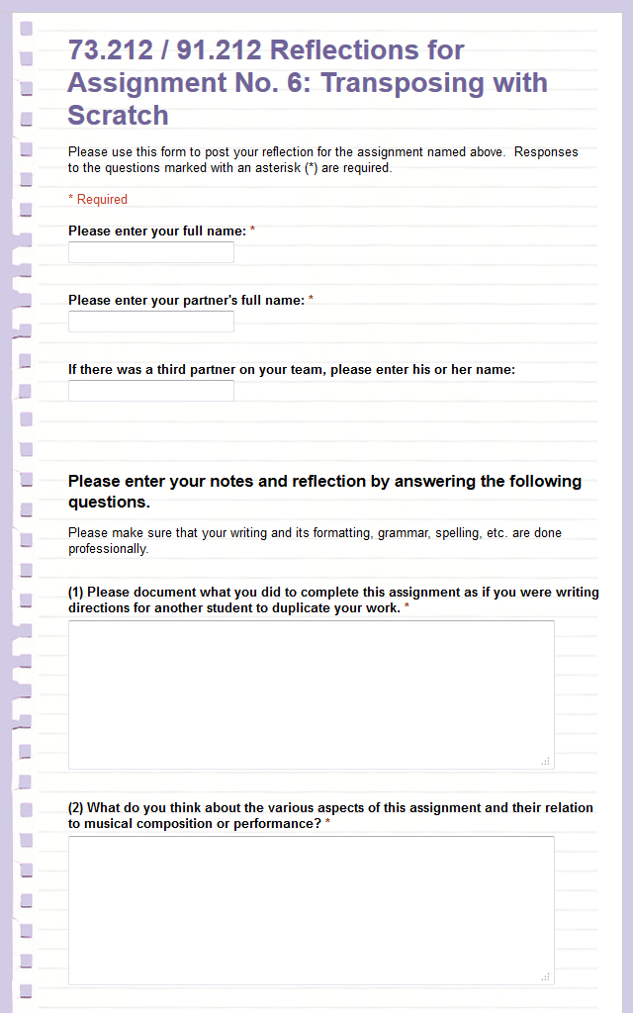

*Figure 8-1a.* Google form for students to submit their reflection on Assignment No. 6, part 1.

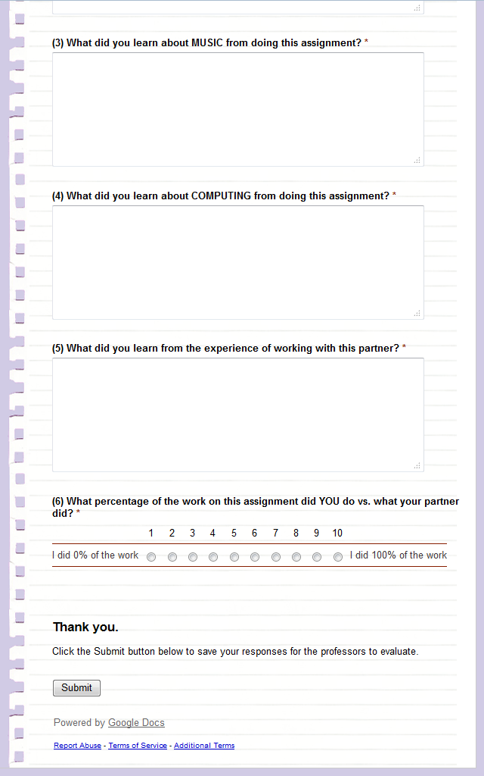

*Figure 8-1b.* Google form for students to submit their reflection on Assignment No. 6, part 2.

but it stops short of asking really specific questions on the assignment content itself. There’s a fine line here, and we have gone back and forth across it a number of times. Yes, we want to provide structure, but we also want students to think for themselves.

Notice that we also included a rating scale at the end of the form so that students could indicate their own assessment of how much they personally contributed to the assignment. In grading collaborative assignments, it’s often difficult to assess who contributed what. We generally assign all contributors to a particular assignment the same grade, but we have found that in some cases, one person drops off the radar screen, leaving it to her/his partner to complete the work. Even without the rating scale, the person left doing the work will often, but not always, make note of their partner’s absence within the text of their reflection. In any event, we don’t believe that the student who contributed little to nothing to the assignment should receive the same grade as the one who did all of the work, and we suspect you would agree with that philosophy.

It’s hard to say exactly where the line should be drawn, but the result for us has been almost revolutionary. More students submitted the reflection part of the assignments, the submissions themselves were *much* longer and more detailed, and the quality of the writing improved, as well. We’re not exactly sure why this is so. Maybe students felt more comfortable writing online. Maybe the minimal structure we provided was all they needed to get their written thoughts flowing. Or maybe the simple presence of a form tripped some conditioned response that if you’re presented with a form, you react by filling it out. We have not really explored the reasons why the forms worked so well, but we were of course happy to see such positive changes in the students’ reflections.

You will discover though, that processing the forms introduces another wrinkle, however. When students write multiple paragraphs it is hard to view the entire reflection on a single screen (see Figure -). Comparing reflections submitted by partners in the same pair or team also becomes difficult online, because to do that you have to jump all around the spreadsheet. The Google Forms “show summary of responses” is of little help either, as that only displays the first hundred or so characters of text responses.

To display the data in an easier-to-read format, you may wish to download the Google Forms spreadsheet as an Excel spreadsheet. That makes the voluminous text much easier to read, because you can more easily expand columns. In addition, Excel appears to be a more stable environment for reading. If you and your partner have the technical skills, you can write Visual Basic macros to convert it to an even more readable form, such as that shown in Figure -.[3] This makes the information much easier to process and digest.[4]

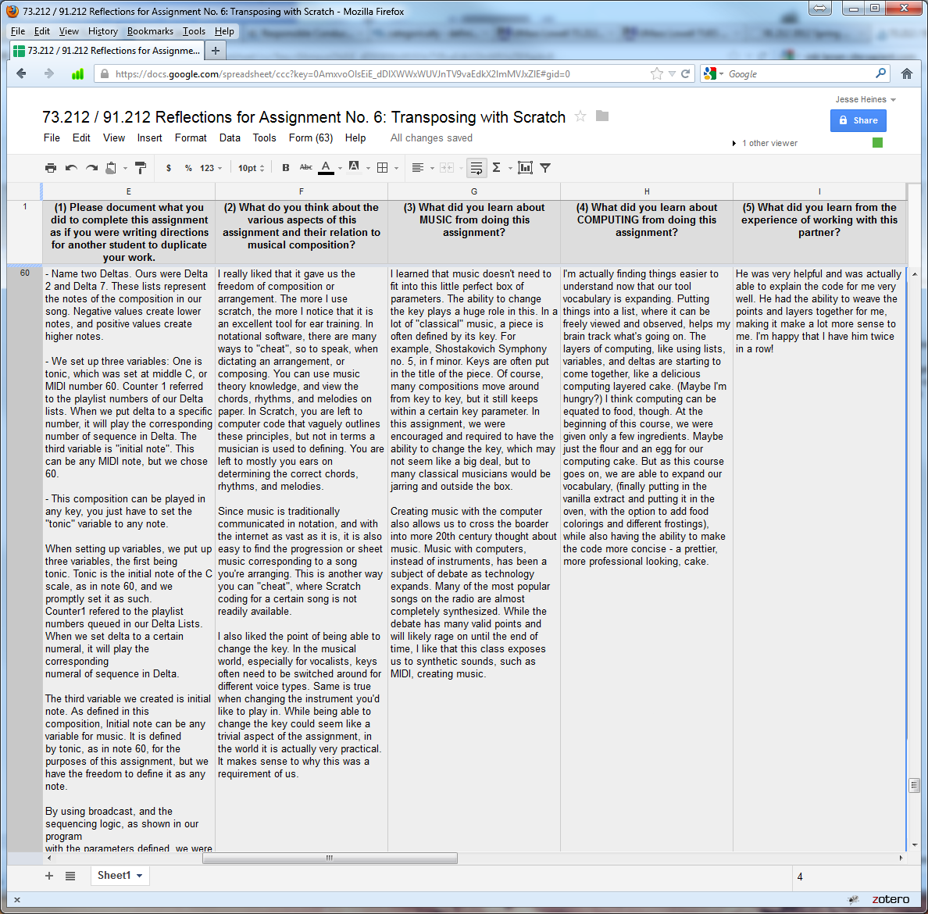

*Figure 8-2.* Lengthy student reflection text responses as they appear in the spreadsheet that Google uses to store submitted form data.

|  |
| --- |
| Submission No. 26  Submission Time Stamp: 4/10/2012 10:13:41 AM  Student Name: (name removed for publication)  Partner Name: (name removed for publication)  Third Partner: None  Percent of Work Claimed to be Done by This Student: 40 %  Response to Question 1:  Please document what you did to complete this assignment as if you were writing  directions for another student to duplicate your work.  - Name two Deltas. Ours were Delta 2 and Delta 7. These lists represent the  notes of the composition in our song. Negative values create lower notes,  and positive values create higher notes.    - We set up three variables: One is tonic, which was set at middle C, or  MIDI number 60. Counter 1 referred to the playlist numbers of our Delta  lists. When we put delta to a specific number, it will play the  corresponding number of sequence in Delta. The third variable is "initial  note". This can be any MIDI note, but we chose 60.    - This composition can be played in any key, you just have to set the  "tonic" variable to any note.    When setting up variables, we put up three variables, the first being  tonic. Tonic is the initial note of the C scale, as in note 60, and we  promptly set it as such.  Counter1 referred to the playlist numbers queued in our Delta Lists.  When we set delta to a certain numeral, it will play the corresponding  numeral of sequence in Delta.    The third variable we created is initial note. As defined in this  composition, Initial note can be any variable for music. It is defined  by tonic, as in note 60, for the purposes of this assignment, but we  have the freedom to define it as any note.    By using broadcast, and the sequencing logic, as shown in our program  with the parameters defined, we were able to compose a musical piece  in Scratch.    Any key can be played by our program, one simply has to define the  tonic to that specific note, and our initial note will start with said  directions.  Response to Question 2:  What do you think about the various aspects of this assignment and their  relation to musical composition?  I really liked that it gave us the freedom of composition or arrangement.  The more I use scratch, the more I notice that it is an excellent tool for  ear training. In notational software, there are many ways to "cheat", so to  speak, when dictating an arrangement, or composing. You can use music  theory knowledge, and view the chords, rhythms, and melodies on paper. In  Scratch, you are left to computer code that vaguely outlines these  principles, but not in terms a musician is used to defining. You are left  to mostly you ears on determining the correct chords, rhythms, and  melodies.    Since music is traditionally communicated in notation, and with the Internet  as vast as it is, it is also easy to find the progression or sheet music  corresponding to a song you're arranging. This is another way you can  "cheat", where Scratch coding for a certain song is not readily available.    I also liked the point of being able to change the key. In the musical  world, especially for vocalists, keys often need to be switched around for  different voice types. Same is true when changing the instrument you'd like  to play in. While being able to change the key could seem like a trivial  aspect of the assignment, in the world it is actually very practical. It  makes sense to why this was a requirement of us.  Response to Question 3:  What did you learn about MUSIC from doing this assignment?  I learned that music doesn't need to fit into this little perfect box of  parameters. The ability to change the key plays a huge role in this. In a  lot of "classical" music, a piece is often defined by its key. For example,  Shostakovich Symphony no. 5, in F minor. Keys are often put in the title of  the piece. Of course, many compositions move around from key to key, but it  still keeps within a certain key parameter. In this assignment, we were  encouraged and required to have the ability to change the key, which may  not seem like a big deal, but to many classical musicians would be jarring  and outside the box.    Creating music with the computer also allows us to cross the border into  more 20th century thought about music. Music with computers, instead of  instruments, has been a subject of debate as technology expands. Many of  the most popular songs on the radio are almost completely synthesized.  While the debate has many valid points and will likely rage on until the  end of time, I like that this class exposes us to synthetic sounds, such as  MIDI, creating music.  Response to Question 4:  What did you learn about COMPUTING from doing this assignment?  I'm actually finding things easier to understand now that our tool  vocabulary is expanding. Putting things into a list, where it can be freely  viewed and observed, helps my brain track what's going on. The layers of  computing, like using lists, variables, and deltas are starting to come  together, like a delicious computing layered cake. (Maybe I'm hungry?) I  think computing can be equated to food, though. At the beginning of this  course, we were given only a few ingredients. Maybe just the flour and an  egg for our computing cake. But as this course goes on, we are able to  expand our vocabulary, (finally putting in the vanilla extract and putting  it in the oven, with the option to add food colorings and different  frostings), while also having the ability to make the code more concise -- a  prettier, more professional looking, cake.  Response to Question 5:  What did you learn from the experience of working with this partner?  He was very helpful and was actually able to explain the code for me very  well. He had the ability to weave the points and layers together for me,  making it make a lot more sense to me. I'm happy that I have him twice in a  row! |

*Figure 8-3.* Lengthy student reflection text responses as they appear after processing by Excel macros.

## Accepting Multimedia Student Submissions

We tried a number of ways to handle students’ multimedia submissions. We experimented with a number of websites that allow program and sound files to be uploaded to them, but none turned out to be quite right for our purposes.[5] For those of you who are teaching at schools that have easy to navigate course websites, this may not be an issue. In our case, we set up our own system using the following procedure.

1. We created a new gmail account for our course.
2. We instructed students to email their submissions for each assignment to the course account after naming their files in a standard manner. For example, the file name for the Scratch file submitted for Assignment No. 6 needed to be in the format: YourLastName_YourFirstName_PartnerLastName_PartnerFirstName_ Assn6_TransposingUsingLists.sb
3. We then moved the files to a web server where we could both access them (see Figure 8-). If you are not teaching with a partner, or if you have a small class, you might find this additional step unnecessary.
4. This procedure worked very well for us. It gave us both access to all student submissions from home as well as from our university offices, and it allowed us both to look at a specific submission as we discussed it on the phone, which we did more often for excellent submissions than for poor ones. We have also found that sites such as Edmodo (www.edmodo.com) will let students upload their multimedia files if they are smaller than 100 MB.

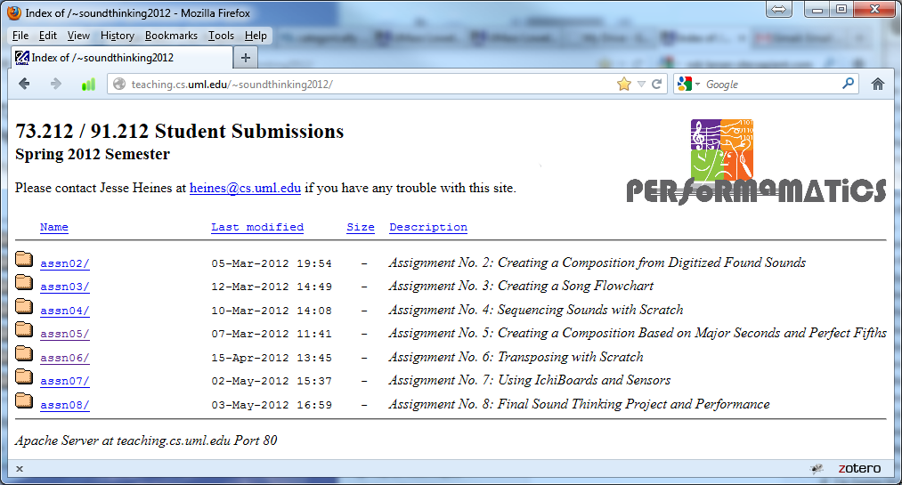

*Figure 8-4.* Website for assignments to be graded.

## Grading Logistics

We have now described how you might access all of the components of your students’ assignments, including their reflections. The next step, of course, is to actually go about grading all their work. How do two instructors teaching an interdisciplinary course together communicate what they’re thinking and agree on what grade to award to each student team?

The first answer to that question is that it isn’t easy. To begin, the instructors need to discuss their expectations before they start grading. The discussion actually begins at the point the assignment parameters are created, by carefully reviewing the “How You Will Be Graded” section discussed previously. Since time — or lack thereof — is a critical issue for professors as well as students, finding the time to sit down together to review each assignment is probably not feasible. More often than not you will find yourselves grading these assignments separately and at odd hours. Our solution is to create a shared Google Docs Spreadsheet like that shown in Figure -, with columns for each of the major grading criteria and comments from each of the graders. This allows you to not only both work on the grading at the same time, but also to see each other’s comments instantaneously, allowing you to sometimes refer to the other’s comments in your own.

Note particularly Column J in Figure -5, which shows the difference between the total scores we each assigned to individual students. When the difference is 0, we had given the same score. When it was negative, Jesse had given a lower score than Gena. When it was positive, the reverse was true.

When we first started teaching together, we wanted to give students one grade that was awarded by both of us. But as we gained experience, we decided to keep our grades distinct so that students could see the difference in our perspectives. We don’t want the difference to be too large, however, so we agreed that we would leave differences of plus or minus 2 points alone, but if we differ by more than 2 points, we discuss that student’s work to try to understand why. In these cases, one of us typically adjusts his or her grade to be within 2 points of the other’s. It is a very rare occurrence when our differences are so large that we both have to adjust our grades.

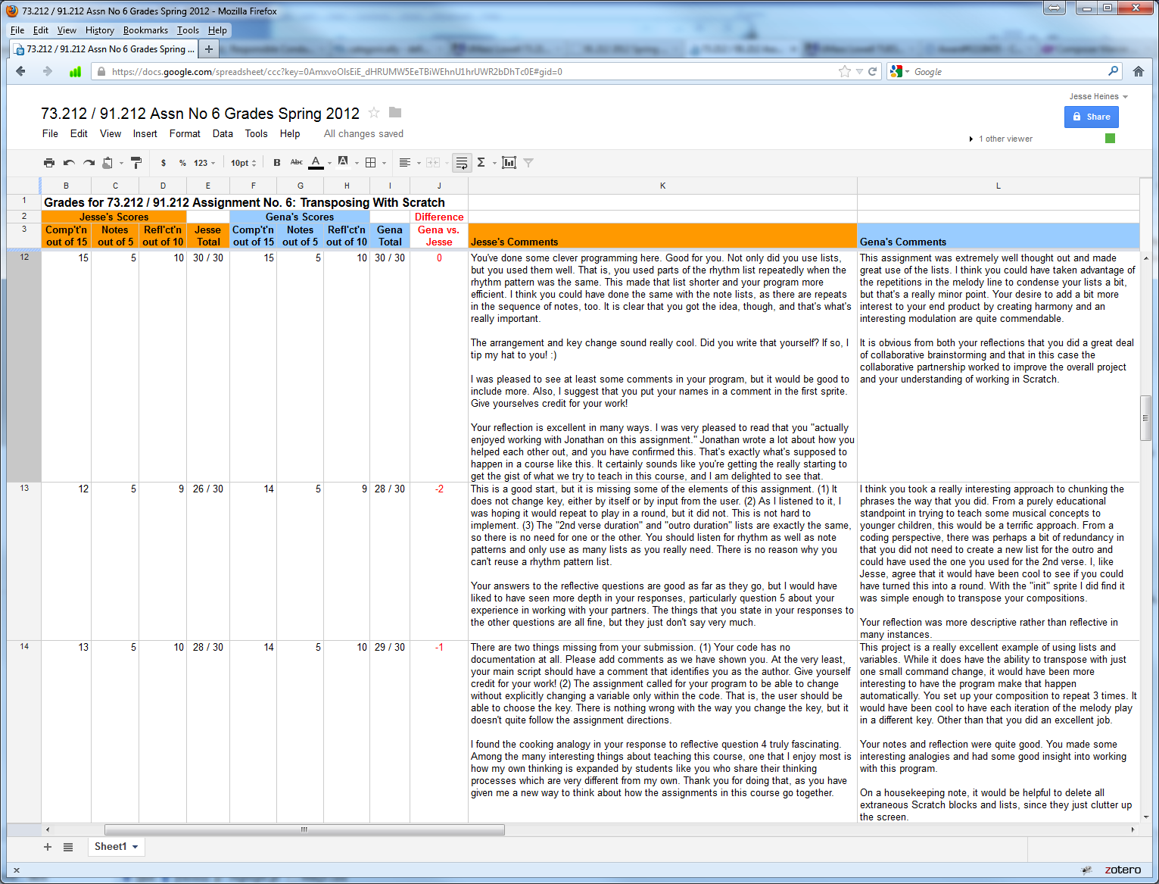

*Figure 8-5.* Google Docs grading spreadsheet.

As with student reflections, the information entered into the Google Docs spreadsheet has to be transformed into a more readable form to provide students with feedback. In addition, we obviously needed to extract each student’s grades and comments so that we could email these to students individually. It wouldn’t be too big of a job to do this manually for a small class, but we devised an automated procedure similar to that for the students’ reflections: we downloaded the Google Docs spreadsheet as an Excel file and processed it using Visual Basic macros to write out text files that we could email to each student. Figure - shows a sample grade report generated for the second student in Figure -5.

## Grading the Professors

It is customary to think of grading in terms of evaluating the performance and progress of students. However, grading can also be a means for educators to evaluate how well they themselves are conveying course concepts. Assuming that we are not victims of grade inflation, we are probably safe in assuming that if we have few seriously low or failing grades, we have done a reasonably good job of teaching.

Most colleges and universities also have a system of student evaluations of teaching (SETs) that are administered at the end of each semester, as ours does. Our standard SET form is geared toward a professor’s performance, demeanor, effectiveness, availability for help, and classroom environment. Given that *Sound Thinking* is breaking new ground in many areas, we were looking to determine the effectiveness of the course itself, as well as changes in students’ thinking and beliefs about the course content.

|  |
| --- |
| Subject: 73.212 / 91.212 Grade Report  Assn. No. 6: TRANSPOSING WITH SCRATCH  Date Due: April 12, 2012  Student: (name removed for publication)  GRADES  Scores from Jesse  Composition: 12  Notes: 5  Reflection: 9  Scores from Gena  Composition: 14  Notes: 5  Reflection: 9  Total Grade: 54 out of 60  COMMENTS  From Jesse:  This is a good start, but it is missing some of the elements of  this assignment. (1) It does not change key, either by itself or  by input from the user. (2) As I listened to it, I was hoping it  would repeat to play in a round, but it did not. This is not  hard to implement. (3) The "2nd verse duration" and "outro  duration" lists are exactly the same, so there is no need for one  or the other. You should listen for rhythm as well as note  patterns and only use as many lists as you really need. There is  no reason why you can't reuse a rhythm pattern list.    Your answers to the reflective questions are good as far as they  go, but I would have liked to have seen more depth in your  responses, particularly question 5 about your experience in  working with your partners. The things that you state in your  responses to the other questions are all fine, but they just  don't say very much.  From Gena:  I think you took a really interesting approach to chunking the  phrases the way that you did. From a purely educational  standpoint in trying to teach some musical concepts to younger  children, this would be a terrific approach. From a coding  perspective, there was perhaps a bit of redundancy in that you  did not need to create a new list for the outro and could have  used the one you used for the 2nd verse. I, like Jesse, agree  that it would have been cool to see if you could have turned this  into a round. With the "init" sprite I did find it was simple  enough to transpose your compositions.    Your reflection was more descriptive rather than reflective in  many instances. |

*Figure 8-6.* Sample individual student grade report generated by Visual Basic macros run on the Google Docs grading spreadsheet in Figure -5. This is the form in which the report is emailed to students.

Toward this end, and with the help of our Performamatics colleagues including our evaluators, we created pre- and post-course surveys in an attempt to assess overall course effectiveness and identify areas of weakness.

Like our project reflection forms, we created these surveys using Google Forms. (See Appendix 8a for the actual forms used.) These were somewhat anonymous surveys, but we asked students to enter the last four digits of their student ID numbers so that we would have the possibility of contrasting their pre-course responses to their post-course responses. In the pre-course survey, we also asked questions about their majors and whether they were taking the course specifically to fulfill their GenEd requirement. Other questions were designed to help us understand how balanced the course was between music and computing content, what projects were particularly effective, and the students’ views on creating music using computers. Finally, we asked some technical questions to give us insight into how well some of the key concepts learned in the course were internalized.

With regard to how well *Sound Thinking* met students’ expectations, overall we found the results to be positive. For the most part, students felt that they:

* learned new ways of making music and composing
* gained more knowledge of computing and programming
* learned to collaborate with people outside their major,
* were more willing to take risks in this course
* felt their ability to communicate ideas was improved
* learned to think more creatively

We then asked the students to elaborate on their perceptions of the changes they underwent during the length of the course. As expected, many students did not feel that they changed at all. However, comments such as “By taking risks, we are asked to apply our knowledge base to create new applications and original developments to unsolved problems,” were fairly typical of those who felt they had changed.

In terms of computing+music and ways of thinking, we found that in general, students’ comfort levels working with computers and music increased and most believed that one can create music with very little formal training and work with computers with little knowledge of programming languages. Students felt an increased ability to break down problems to their component parts, diagnose problems, recognize patterns, and work through some of the frustrations that one inevitably encounters when learning new concepts and technologies.

Jesse and Gena both advise undergraduates, and the fact students come in asking if they can take *Sound Thinking* because they heard it was cool suggests that the “word on the street” about the course is fairly positive. This anecdotal evidence is corroborated by survey results in which more students than not say they got a great deal out of the collaborative nature of the projects and working with a diverse group of people. They also say that they learned many of the core concepts that were taught, are beginning to appreciate the integration of music and computing, and realize the similarities between musical and computational thinking.

At the beginning of each semester in which we teach this course, we review survey results to inform the content and delivery methods for the next iteration of *Sound Thinking*. We consider this course and our collaboration to be “works in progress,” and as such we will continue to evaluate our own performance as well as that of our students.

## Bibliography for Chapter

[1] Hetland, L., Winner, E., Veenema, S., & Sheridan, K.M. (2007). *Studio Thinking: The Real Benefits of Visual Arts Education*. New York: Teachers College Press.

1. We used Google Groups for quite a while in our classes, but we have now found that Piazza, a free service available at www.piazza.com, or Edmodo, another free service at www.edmodo.com, are particularly well suited for online class discussions.
2. For readers unfamiliar with IRBs, this is a university office that is responsible for ensuring, among other things, that students in experimental courses such as our are not taken advantage of. For example, students must first be fully informed that their enrollment in the course makes them part of a research study. They must voluntarily agree to take part, and they must be allowed to opt out of certain aspects of the study such as our use of their work and likenesses in our publications and presentations. IRB approval is required for all research at our university, particularly research that involves using students as subjects and is funded by the National Science Foundation.
3. Gena likes to say, “It’s so nice to have a real CS prof on the team.” ☺
4. The macros we used to do this are freely available from the book website.
5. We do not want to list all the websites we tried to use for our course, as we don’t want to “bad mouth” them. Some might be totally appropriate for others’ use, but they didn’t work well for us.